Name :- A.KULLAI REDDY
Reg no:- 192412647

Logisim programs:-
28. Design a circuit for the below mentioned diagram and implement the same using Logisim simulator.
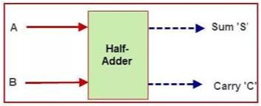

Output :- Logisim

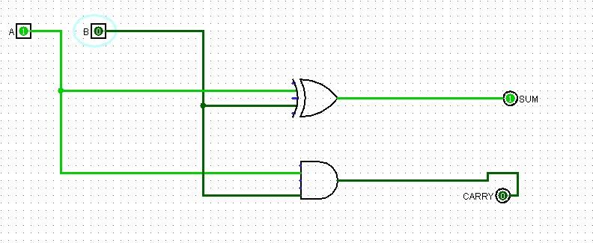

29. Design a circuit for the below mentioned diagram and implement it using Logisim simulator.
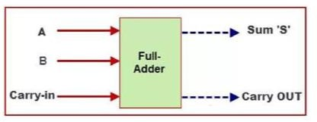

Output :- Logisim

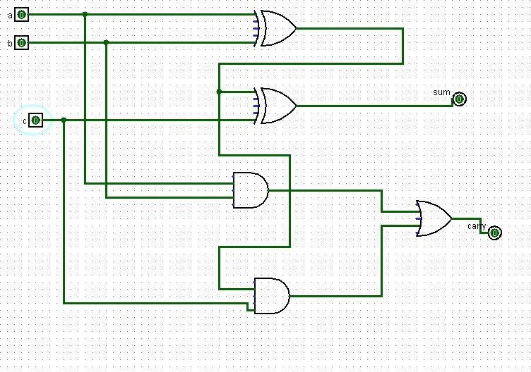

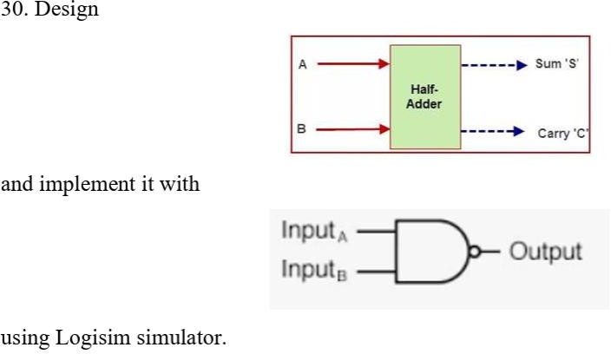

Output :- Logisim

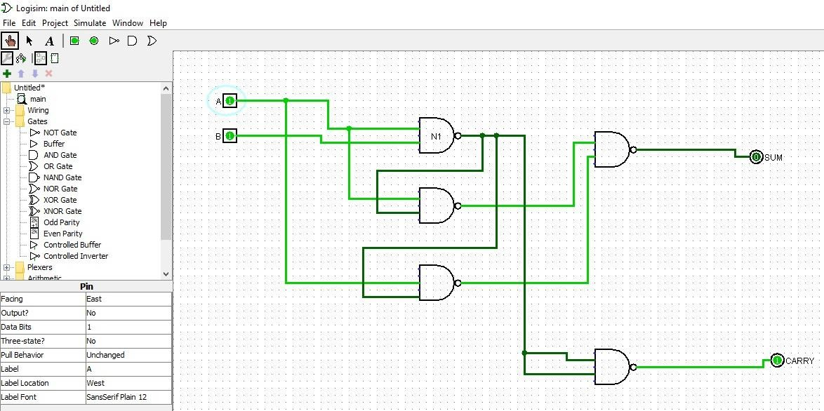

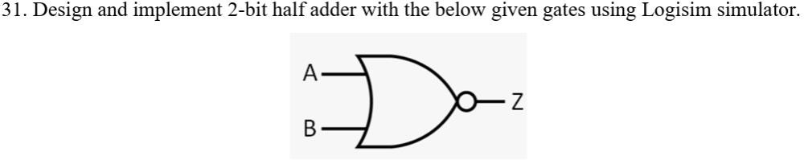

Output :- Logisim

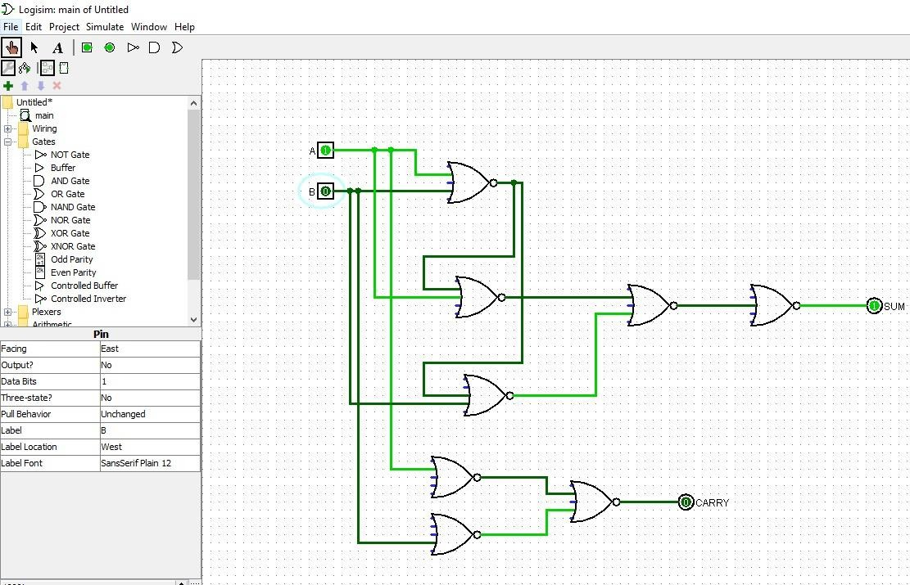

32. Design and implement a Full adder with the below mentioned gate using Logisim simulator.
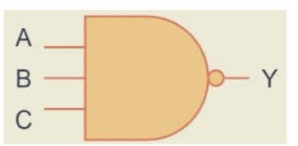

Output :- Logisim
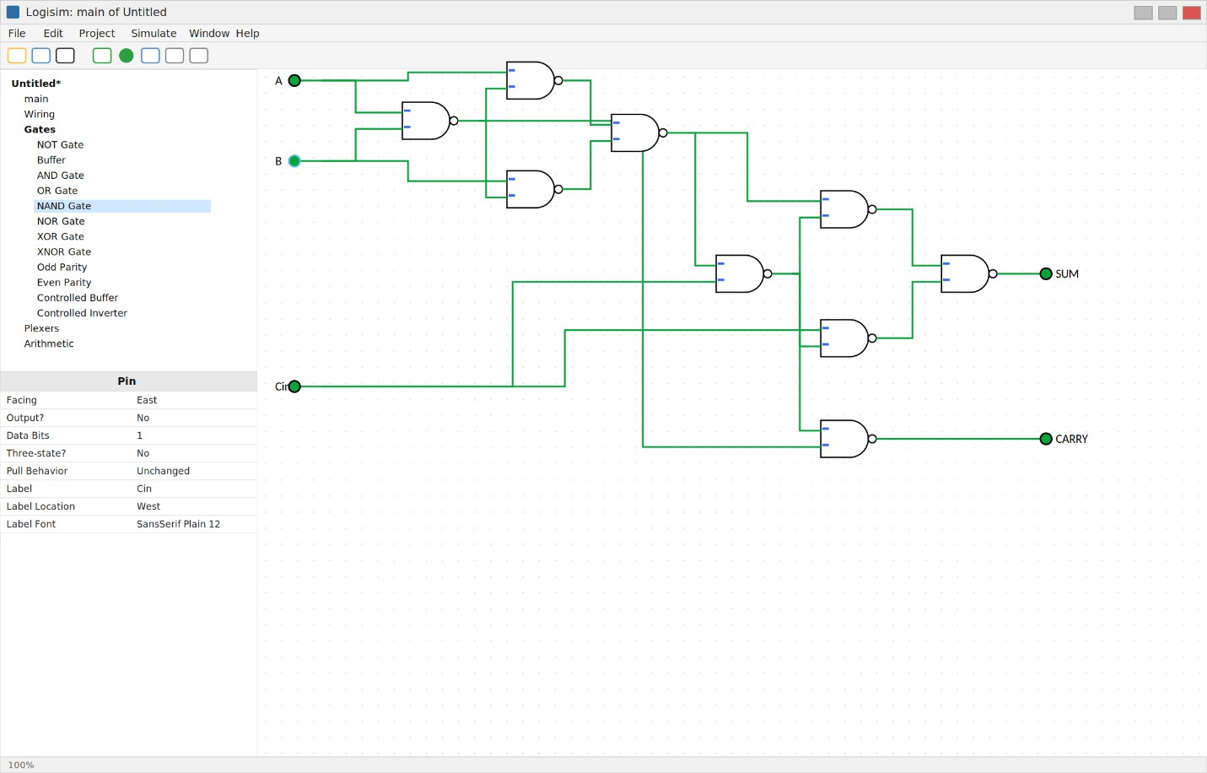

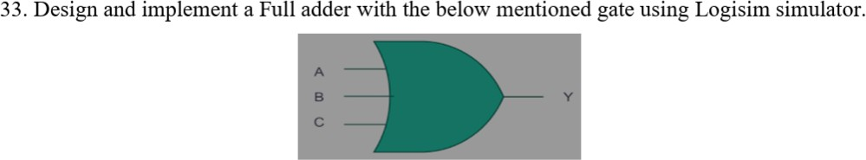

Output :- Logisim

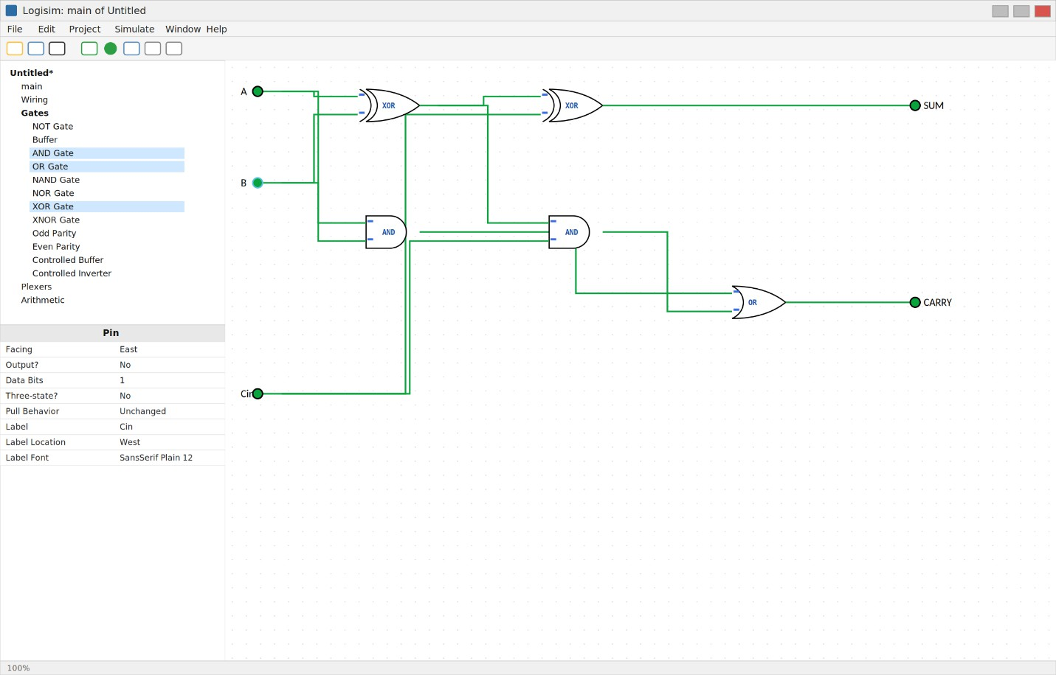

34. Design and implement 4-bit carry look ahead adder circuit using Logisim simulator.

Output :- Logisim
